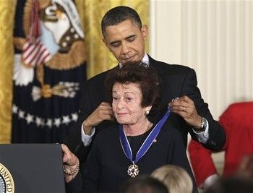
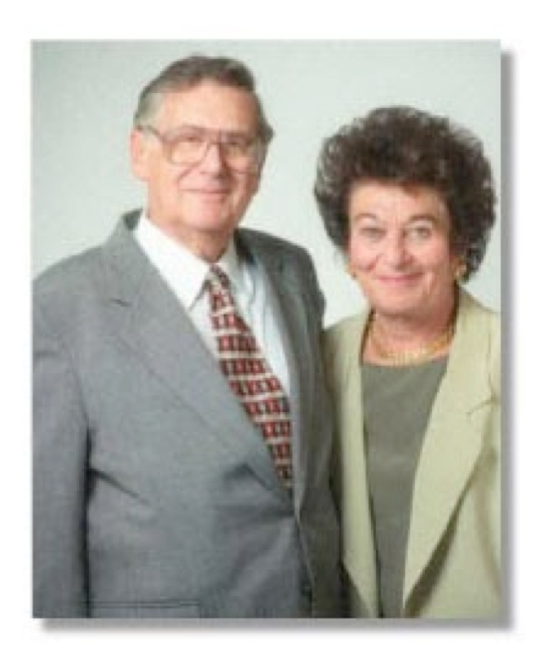


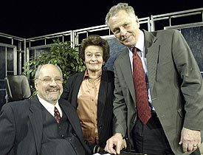
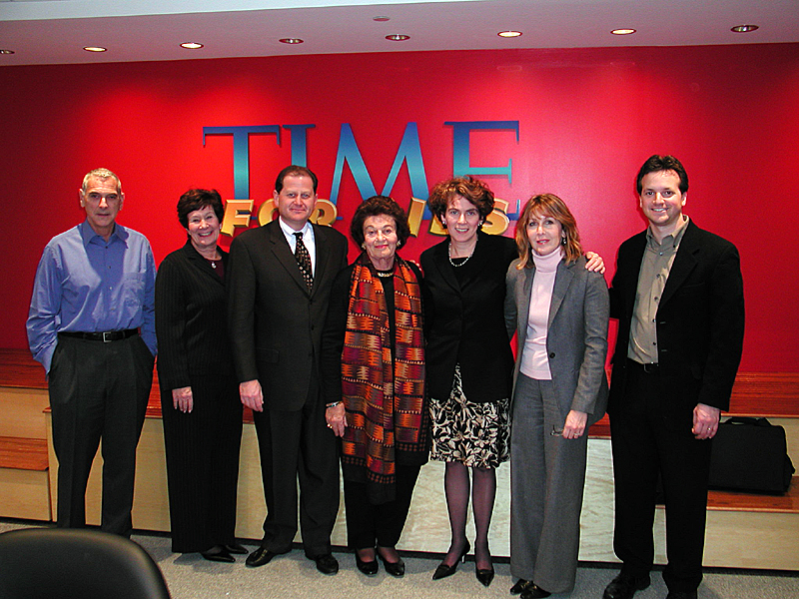
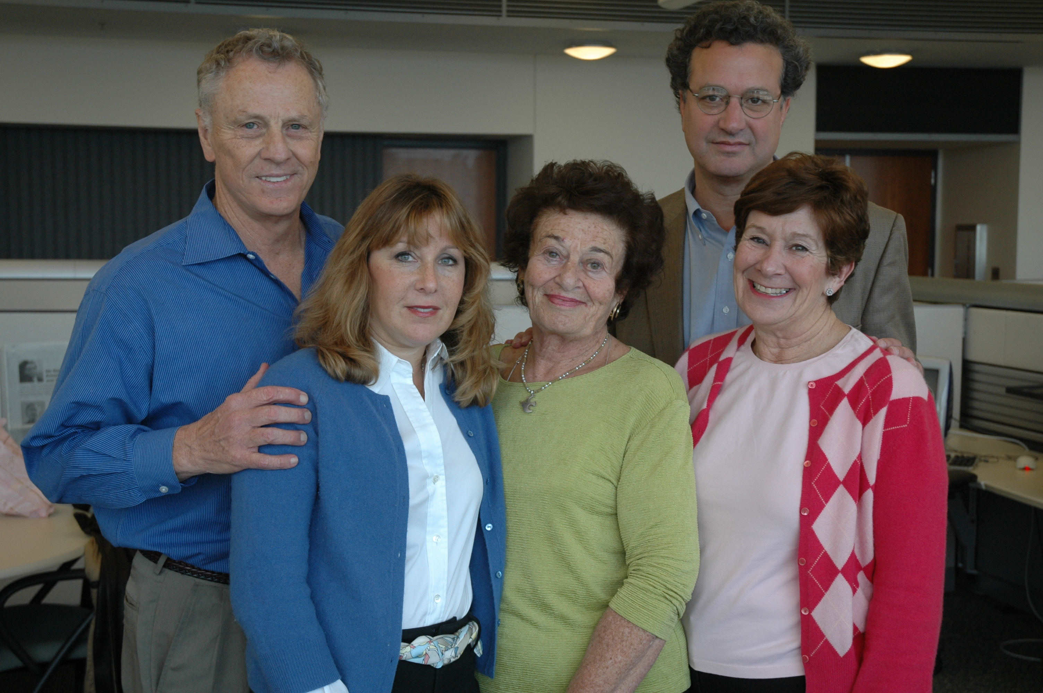
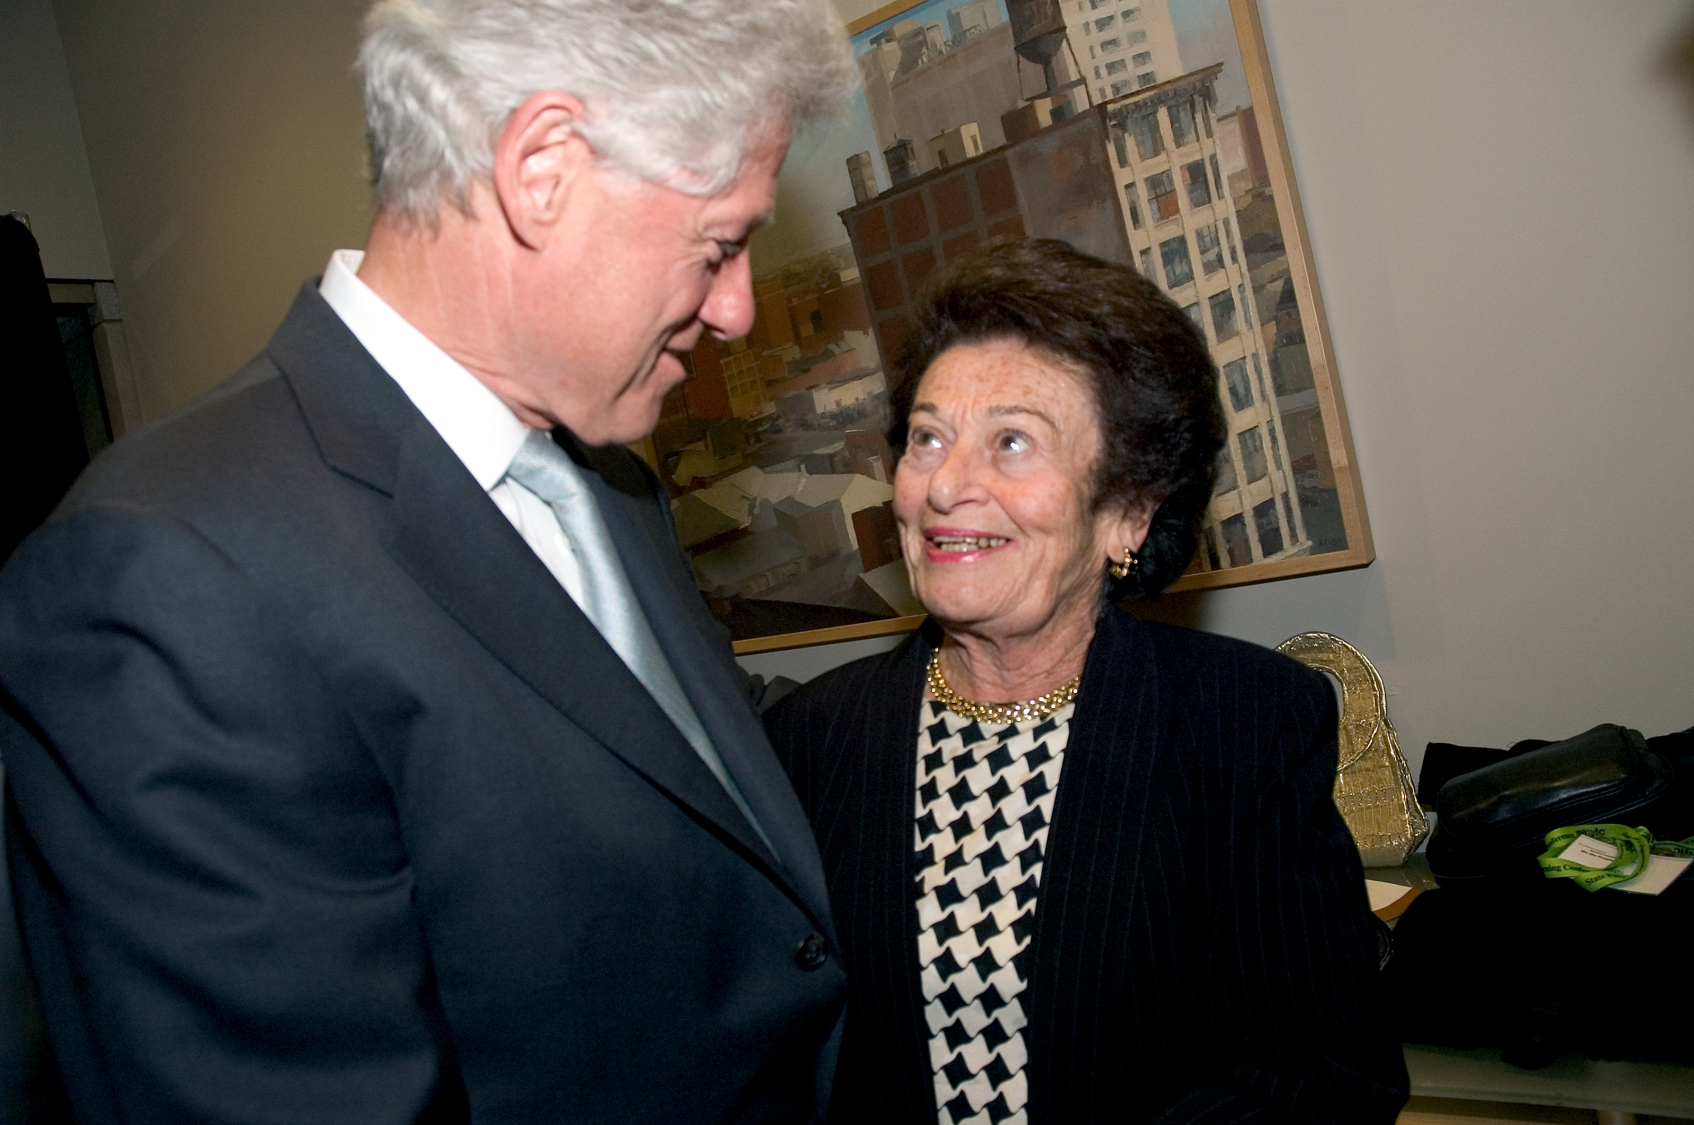
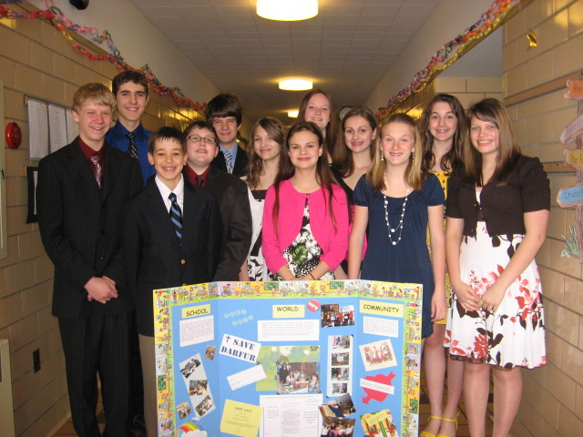
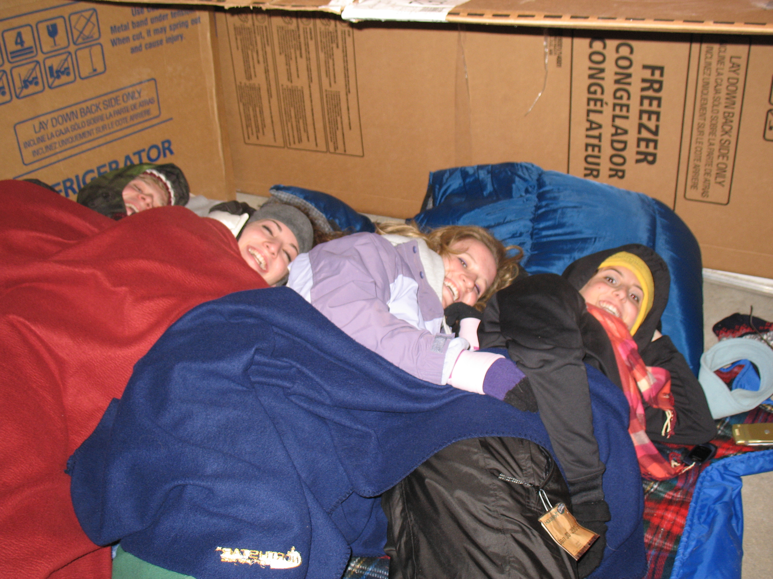
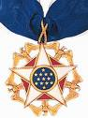
The Gerda and Kurt Klein Foundation will be closing this spring. We will continue to supply our teaching kits to educators around the world through the Southern Poverty Law Center and numerous Holocaust Museums across the country.
The home page of The Klein Foundation website (www.kleinfoundation.org) will have links to order our teaching kits. For more information, please contact Beth Reisboard at breisboard@gmail.com.

“By sharing her stories and encouraging others to see themselves in one another, Gerda Klein has helped to advance understanding among all people...”
President Obama presents the Medal of Freedom to Gerda Klein, February, 2011.

The Klein Foundation’s programs and teaching materials have reached over 14 million students across the globe.
The Gerda and Kurt Klein Foundation was formed in April 1998 to teach students about the importance of tolerance, respect and responsibility through character education and community service. 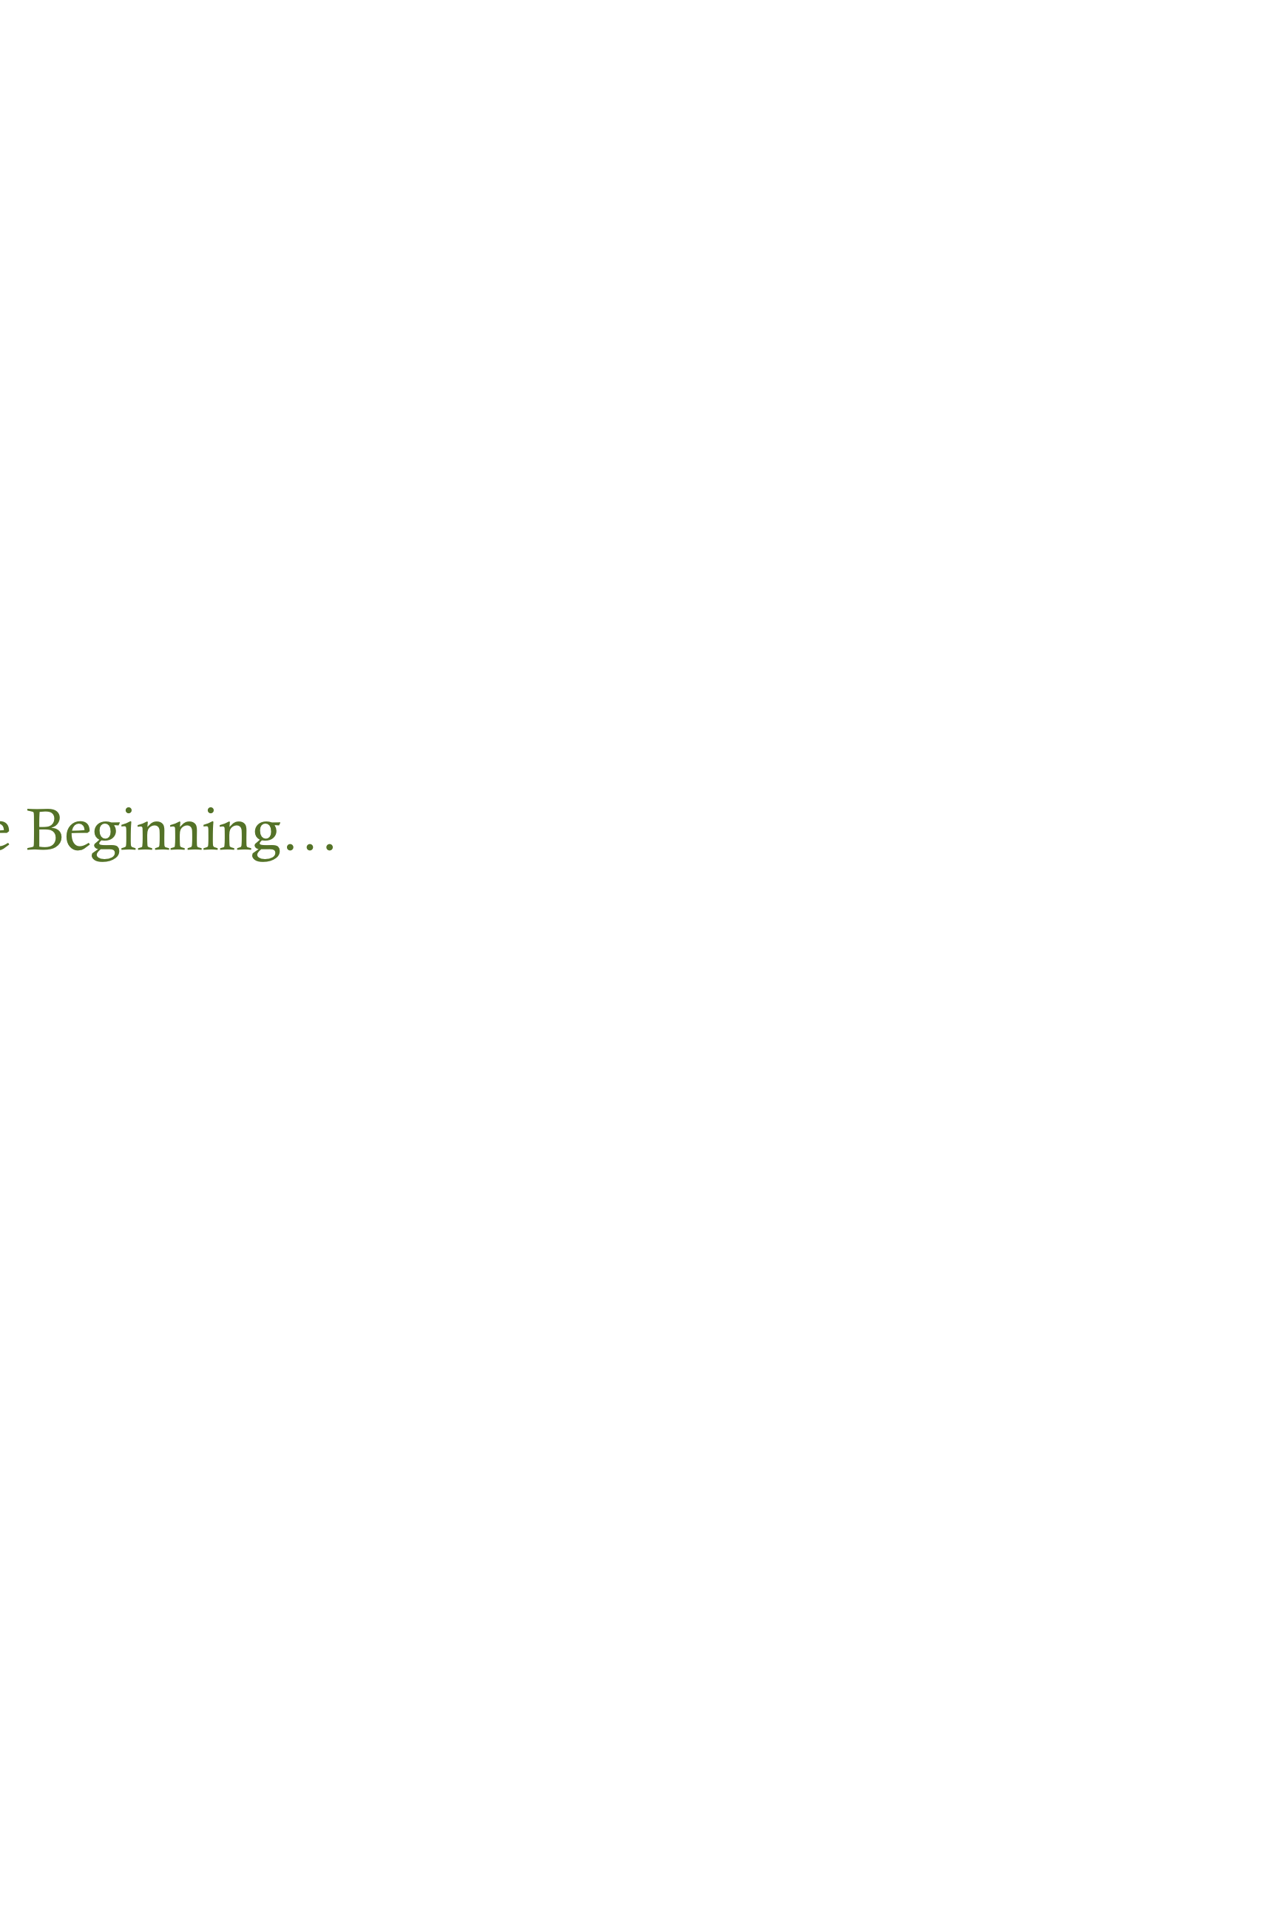the Kleins’ personal message of survival, acceptance and hope, the Foundation’s award winning teaching materials have reached over 14 million students. .

The Result...

Tth

In The Beginning…

The Gerda and Kurt Klein Foundation

  - You Alone Have the Power To Eliminate Bigotry and Hunger
2012
- To date, over 120,000 One Survivor Remembers teaching kits requested and distributed (with an additional 15,000 kits in production today)
- To date, 27,500 Stand Up, Speak Out, Lend A Hand kits distributed (new edition reproduced November 2010)
- KF materials are used in all 50 states and in over 65 countries around the world
(including England, Canada, Mexico, South Africa, China, Ukraine, Former Soviet Union, Austria, Germany, Ghana, Pakistan, Yemen, Nigeria, Peru…)
- KF partnered with MAGPI for numerous interactive videoconferences using internet2 network reaching thousands of middle, high school and college students
- United Nations distributed KF kits to their Information Centres around the globe
- KF received the Jewish Leadership Award from Panim: The Institute for Jewish Leadership and Values. Panim works with young people to integrate Jewish learning and social action

Programs and Projects: Some Highlights
Memories, Voices and Choices: Lessons Learned from the Holocaust and Global Genocides / kNOw Hunger Program and Service Learning Curriculum/Feinstein Youth Hunger Brigade/ Redefining Heroism: Post 9/11 Conference with Principals from New York City High Schools / TIME Classroom: Stand Up, Speak Out, Lend A Hand / Southern Poverty Law Center and Teaching Tolerance: One Survivor Remembers Teaching Kit / Coexistence Festival : My Sister Program / International Holocaust Education Conference at Yad Vashem /Voices In The Family: Gerda Klein and Morris Dees at WHYY (local NPR)/United Nations / LeFrak Holocaust Education Conference/MAGPI Interactive Video Conferences/40th Annual Scholars Conference on the Holocaust and Churches

What We Have Accomplished
FROM THE TEACHERS:
Please let Mrs. Klein know that her fingerprints are on my soul. –--G.G., Selma, California
Thank you so much for inspiring me to become a better person and better educator. -Carol, New Jersey
I cannot begin to express my gratitude for your support. It pains me to know that students in my school are writing “white power” and drawing swastikas on the restroom walls. I really want to make an effort to change our school climate/culture so that we can make the world a better, safer place for everyone. -Marci, Minnesota
We want to thank you for the inspiration you provide and the education your foundation has fostered for us as teachers, and for our students as learners. -Susan, Pennsylvania
Because of you they will better know that there is hope for truth and justice, for tolerance and understanding, for a better world where men and women treat each other with dignity and respect. I thank you for your courage then and now and for your unwavering faith in the goodness of humankind. I send you my personal admiration and offer my prayers that you may continue to be blessed in many ways. With warm and sincere wishes for … the furthering of the wonderful work of your Foundation. -Sister Maria Teresa, Lima, Peru

Students from Christ the Divine School (top left) and Clarence High (above) share photos of their community service projects done as a result of Klein Foundation programs.

Over the past 15 years, we have received hundreds of letters, cards and emails from teachers, experts, and students from around the world. Here is a sample of what we have heard: received…

What We Have Heard….
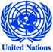 On behalf of the United Nations Holocaust Programme, I would like to express my gratitude to the Gerda and Kurt Klein Foundation for supplying their two teaching kits to the network of UN Information Centres around the world. We have received positive feedback on these materials from the Centres which is evidenced by the continued requests, letters from educators around the world and the use and translation of these materials by various countries where these offices are located. We look forward to continuing our partnership with you. -Juan Carlos Brandt, Chief, Advocacy and Events, Department of Public Information, United Nations
“Gerda Weissmann Klein’s life is a testament to the tenacity of the human spirit. A Holocaust survivor, she was separated from her parents and sent to a series of Nazi labor camps. In 1945, she was one of a few survivors among those forced to undergo a 350-mile death march to avoid the progress of liberating Allied forces. From tragedy to triumph, she and her husband proudly started the Gerda and Kurt Klein Foundation to promote tolerance, respect and empowerment of students throughout the world. By sharing her stories and encouraging others to see themselves in one another, Gerda Klein has helped to advance understanding among all people. “ -President Barack Obama, Medal of Freedom Award Ceremony
On behalf of the Education Division at the United States Holocaust Memorial Museum, let me thank you for all you have done for our teachers. The thousands of teachers who received the packets included not only our master teachers in the Museum Teacher Fellowship Program and the participants in our annual Arthur and Rochelle Belfer National Conference for Educators, but also thousands of novice teachers who have been to the museum but who have not necessarily been able to access the kinds of materials your packets provide. So many teachers come through our doors. It is a real benefit to continue to support them as they seek to educate students about the events of the Holocaust. -Dan Napolitano, USHMM education director

I can give this project the highest possible recommendation. The teaching materials that accompany the film in the teaching kits are well crafted, historically accurate, intellectually rigorous and pedagogically sound. I have witnessed teachers working with these materials and how students respond. These are special works that merit the highest possible distribution. -Michael Berenbaum, writer, lecturer, and teacher consulting in the conceptual development of museums and the development of historical films
FROM THE EXPERTS:
FROM THE EXPERTS:

Stan
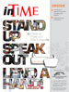
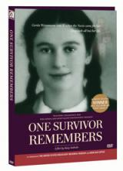
The anchor of the kit is the academy-award winning documentary: One Survivor Remembers. It also includes teacher’s guide, resource guide and primary documents drawn from Mrs. Klein’s personal collection. The primary documents included in this kit allow students not just to see- but also to touch- the lessons of the Holocaust. Somedescribed this as a “traveling museum in a box”.

Your message was one that everyone could relate to, no matter what situation he or she is in. I found your refusal to give into the temptations of hate and revenge to be exceptionally uplifting in a world where forgiveness is too rarely found. I cannot tell you how much your message has meant to all of us. – Michael, Montgomery, Alabama
I n my English class, we watched your movie, One Survivor Remembers. It was truly a heartbreaking movie that made me realize what the Holocaust really was. My class was silent for the whole movie, and for a group of teenagers, that is a rare occasion. –Jamie, Arizona
I sat motionless, completely devoid of thought, clinging to every word she spoke. Each sentence seemed to grab me and slowly peel away my preconceptions of suffering in this world. By the end I was left bare, my soul completely naked, after a myriad of emotions rushed through me simultaneously. I felt as though I could not bare the thought of pain any longer, I felt the need to help, to do something. Never before had I felt anything this powerful. ...it changed my life, my view on the world, and above all it changed me. –Ben, Pennsylvania
I would like to say “I’m sorry.” Why? Because I was one of the people who tried to act like the Holocaust never happened. And that’s why I am apologizing. –Nycieko, North Carolina
Thank you so much for your inspiring story. It makes me think how much of an excellent life I have.” – Clementine, Massachusetts

Stand Up, Speak Out, Lend A Hand
Through this program, the Kleins share their experience of the brutality of bigotry during World War II and afterward, the positive power of service to others. The Klein Foundation TIME CLASSROOM project encourages today’s youth to take an active role in a variety of service projects in their local communities.

ONE SURVIVOR REMEMBERS
FROM THE STUDENTS:
e Students
Michael Berenbaum, Ande Adelman, Bill Norris, Jonathan Rosenbloom, MaryEllen McLaughlin, Joel Schwartzberg, Paula Sincero, Alan Shawn Feinstein and the Feinstein Foundation, Morris Dees, Richard Cohen, Jennifer Holladay, Jeff Sapp, Russell Estes, Valerie Downes, Victoria Williams, Brian Willoughby, SPLC family, Heather Weisse-Walsh and the team at MAGPI, Audrey Cronin, Eric Stern, Ed Glickman, CBIZ, Arthur Zatz, Sara Bloomfield, Dan Napolitano and USHMM, Steve Piltch, Paul Lichtman, Dr. Dan Gottlieb and Maiken Scott of Voices In The Family/WHYY, Share Our Strength, SouperBowl of Caring, Righteous Persons Foundation, Rabbi Israel Miller Fund for Shoah Research, Education and Documentation of the Claims Conference, Sidney Kimmel Foundation, Italian American Pasta Company, Adelson Family Foundation, Sager Family Foundation, Janice Shengold Foundation, McDougall Littell, Gottesman Family Foundation, Esther Finder and GSI, Pennsylvania Holocaust Education Council, New Jersey Holocaust Commission, our Honorary Board of Directors, our hundreds of generous donors and the thousands of dedicated teachers who have continued to be the “messengers to a time I shall not see.”

Gerda Weissmann Klein, Honorary Chair
James Klein, President
Leslie Simon, Vice President
Vivian Ullman, Vice President
Jim Ullman, Vice President
Beth G. Reisboard, Treasurer and Executive Director
Nancy Astor Fox, Associate Director
Honorary Board
Lynne Barrack Edward M. Glickman Sara Minkoff
Michael Berenbaum Daniel Gottlieb Elaine Sager
Diane Farley Janice Shengold

Gerda and Kurt Klein Foundation
James Klein, President
Leslie Simon, Vice President
Vivian Ullman, Vice President
Jim Ullman, Vice President
Beth G. Reisboard, Treasurer and Executive Director
Nancy Astor Fox, Associate Director

Honorary Board
Lynne Barrack Edward M. Glickman Sara Minkoff Michael Berenbaum Daniel Gottlieb ElainSagerSagerDaane Farley Janice Shengold

Special Thanks To
2012

